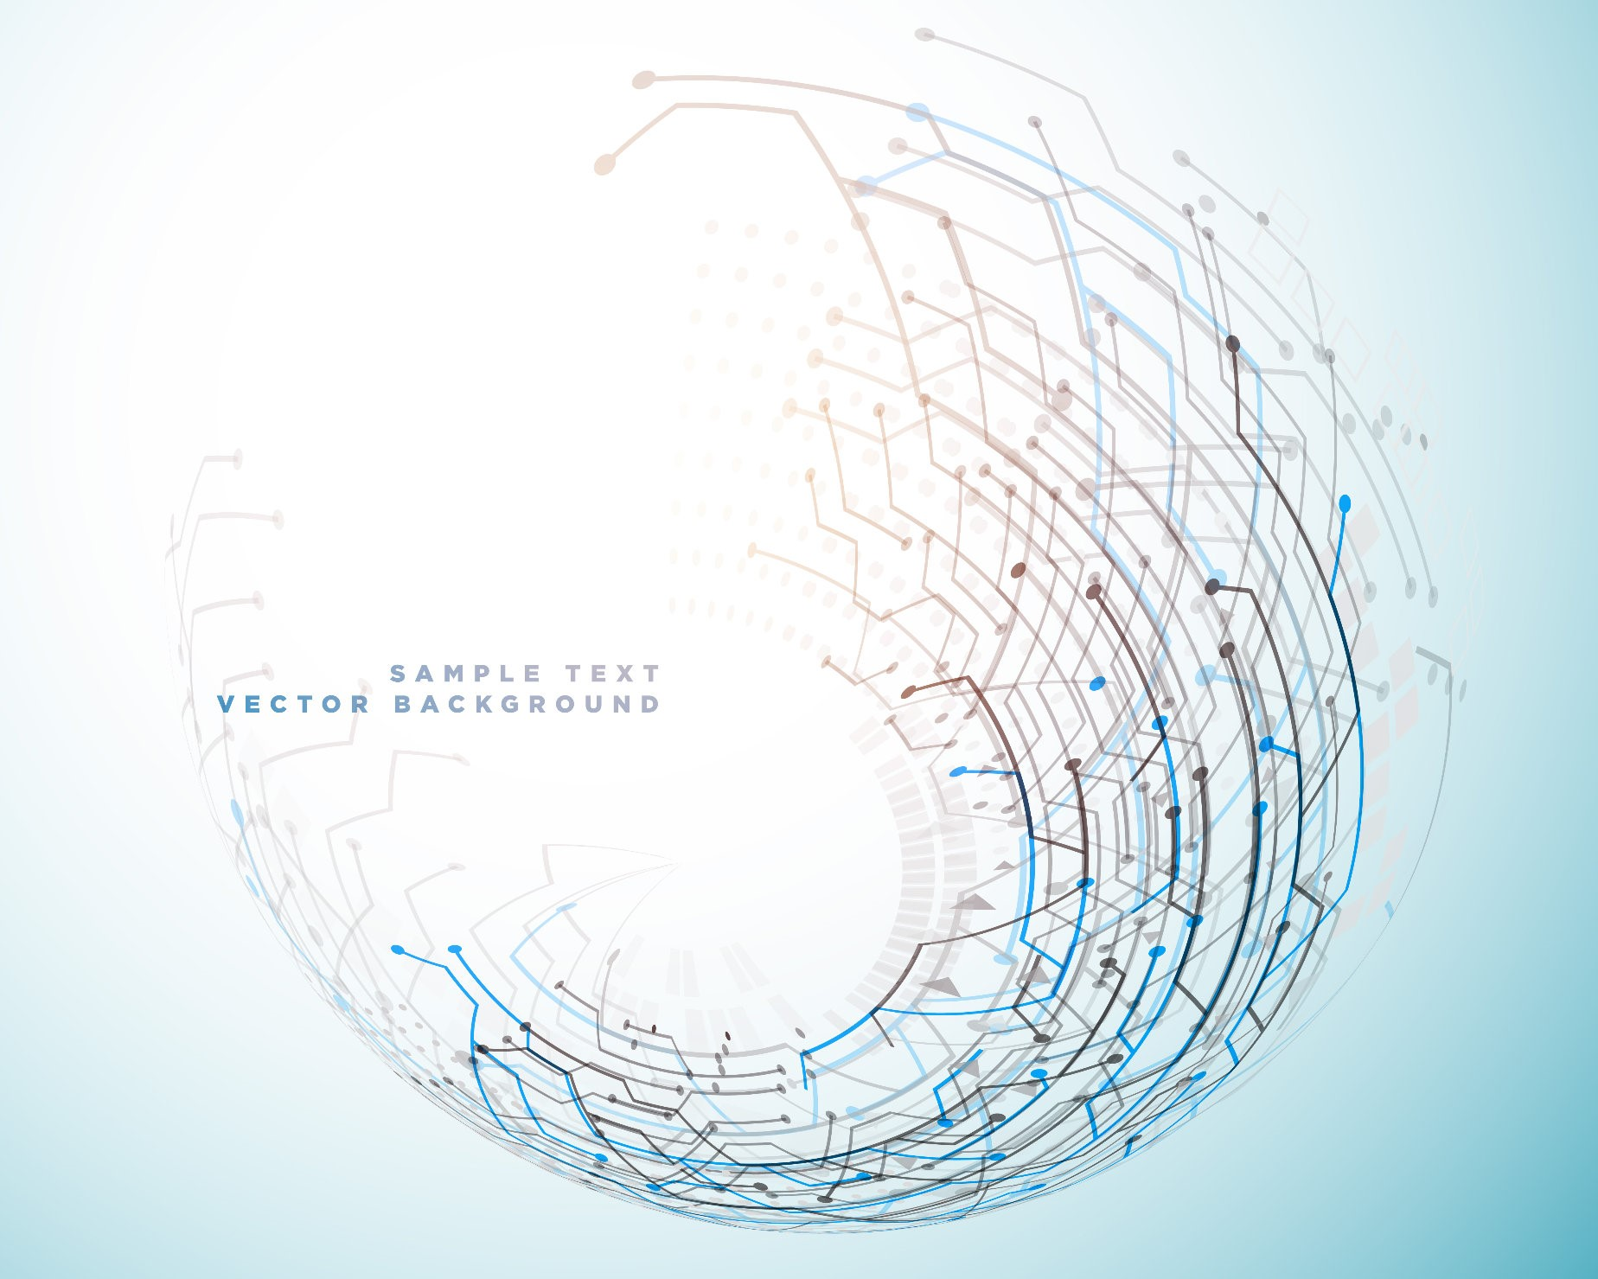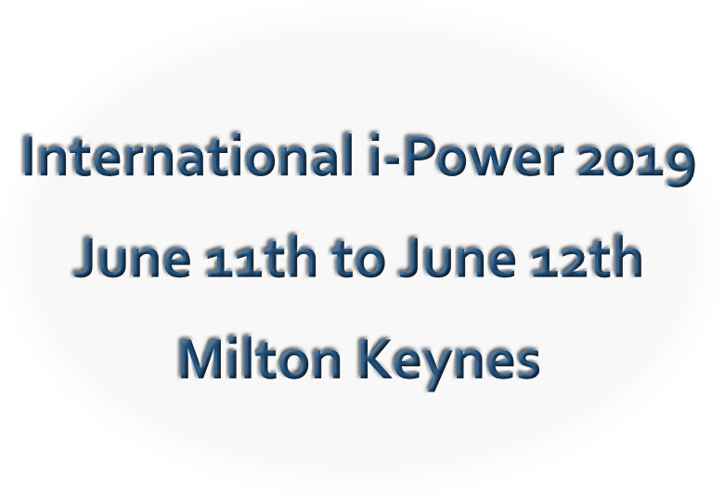

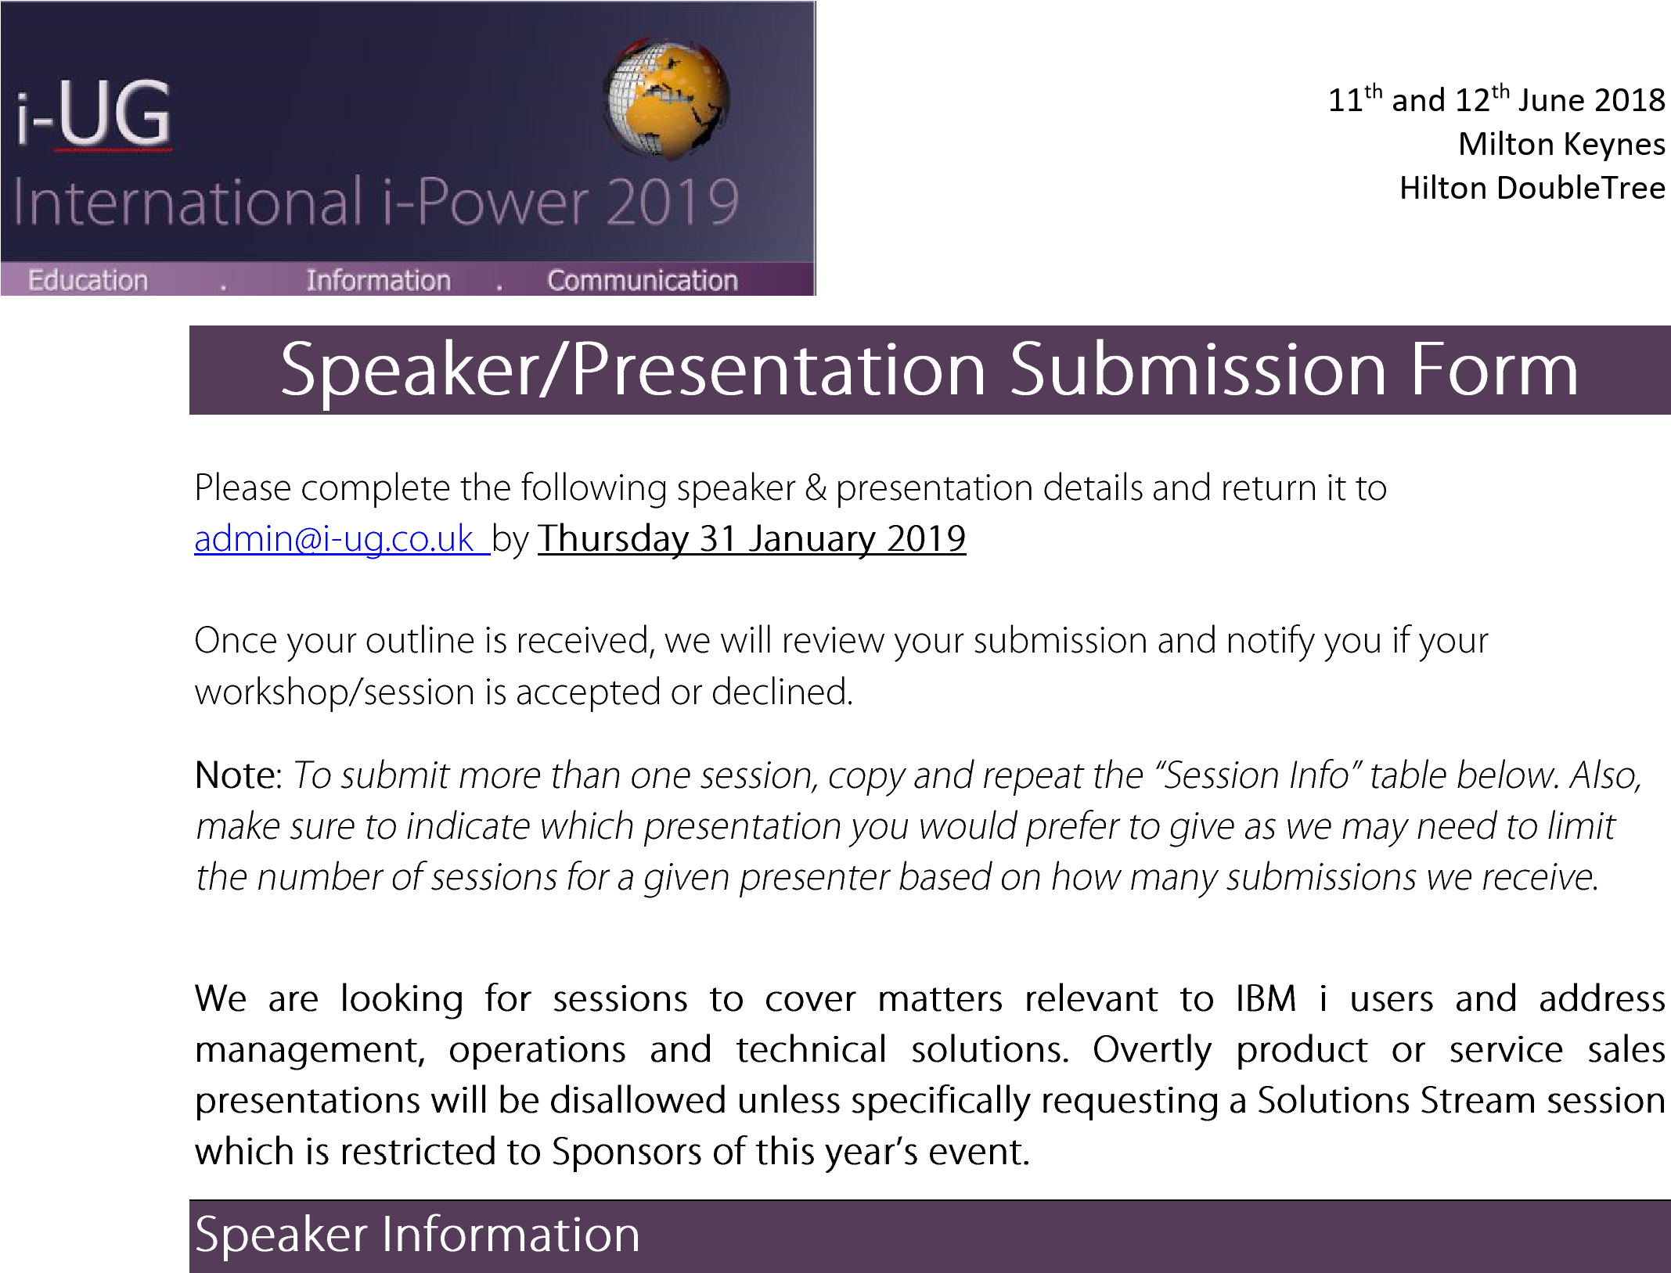

|  |  |
| --- | --- |
|  |  |
|  |  |
|  |  |
|  |  |
|  |  |
|  |  |
|  |  |
|  |  |
|  |  |
|  |  |
|  |  |

11

th

and 12

th

June 2018

Milton Keynes

Hilton DoubleTree



|  |  |
| --- | --- |
|  |  |
|  |  |
|  |  |
|  |  |
|  |  |
|  |  |

